**FHRPS CONCEPTS**

9.0.1

Why should I take this module?

Welcome to FHRP Concepts!

Your network is up and running. You’ve conquered Layer 2 redundancy without any Layer 2 loops. All your devices get their addresses dynamically. You are *good* at network administration! But, wait. One of your routers, the default gateway router in fact, has gone down. None of your hosts can send any messages outside of the immediate network. It’s going to take a while to get this default gateway router operating again. You’ve got a lot of angry people asking you how soon the network will be ‘back up.’

You can avoid this problem easily. First Hop Redundancy Protocols (FHRPs) are the solution you need. This module discusses what FHRP does, and all of the types of FHRPs that are available to you. One of these types is a Cisco-proprietary FHRP called ***Hot Standby Router Protocol (HSRP).*** You will learn how HSRP works and then complete a Packet Tracer activity where you will configure and verify HSRP. Don’t wait, get started!

9.0.2

What will I learn to do in this module?

**Module Title:** FHRP Concepts

**Module Objective**: Explain how FHRPs provide default gateway services in a redundant network.

| Table caption | |
| --- | --- |
| **Topic Title** | **Topic Objective** |
| **First Hop Redundancy Protocols** | Explain the purpose and operation of first hop redundancy protocols. |
| **HSRP** | Explain how HSRP operates. |

**FIRST HOP REDUNDANCY PROTOCOL**

9.1.1

Default Gateway Limitations

If a router or router interface (that serves as a default gateway) fails, the hosts configured with that default gateway are isolated from outside networks. A mechanism is needed to provide alternate default gateways in switched networks where two or more routers are connected to the same VLANs. That mechanism is provided by first hop redundancy protocols (FHRPs).

In a switched network, each client receives only one default gateway. There is no way to use a secondary gateway, even if a second path exists to carry packets off the local segment.

In the figure, R1 is responsible for routing packets from PC1. If R1 becomes unavailable, the routing protocols can dynamically converge. R2 now routes packets from outside networks that would have gone through R1. However, traffic from the inside network associated with R1, including traffic from workstations, servers, and printers configured with R1 as their default gateway, are still sent to R1 and dropped.

**Note**: For the purposes of the discussion on router redundancy, there is no functional difference between a Layer 3 switch and a router at the distribution layer. In practice, it is common for a Layer 3 switch to act as the default gateway for each VLAN in a switched network. This discussion focuses on the functionality of routing, regardless of the physical device used.

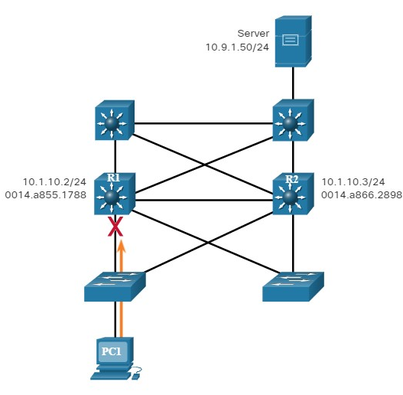

PC1 is unable to reach the default gateway.

End devices are typically configured with a single IPv4 address for a default gateway.

This address does not change when the network topology changes. If that default gateway IPv4 address cannot be reached, the local device is unable to send packets off the local network segment, effectively disconnecting it from other networks. Even if a redundant router exists that could serve as a default gateway for that segment, there is no dynamic method by which these devices can determine the address of a new default gateway.

**Note**: IPv6 devices receive their default gateway address dynamically from the ICMPv6 Router Advertisement. However, IPv6 devices benefit with a faster failover to the new default gateway when using FHRP

9.1.2

Router Redundancy

One way to prevent a single point of failure at the default gateway is to implement a virtual router. To implement this type of router redundancy, multiple routers are configured to work together to present the illusion of a single router to the hosts on the LAN, as shown in the figure. By sharing an IP address and a MAC address, two or more routers can act as a single virtual router.

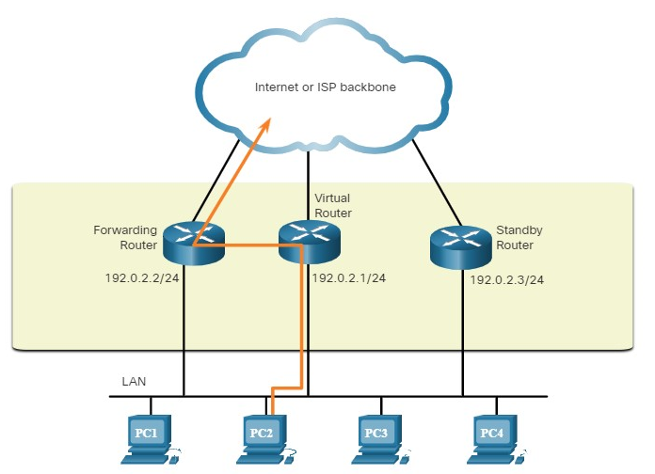

The IPv4 address of the virtual router is configured as the default gateway for the workstations on a specific IPv4 segment.

When frames are sent from host devices to the default gateway, the hosts use ARP to resolve the MAC address that is associated with the IPv4 address of the default gateway. The ARP resolution returns the MAC address of the virtual router. Frames that are sent to the MAC address of the virtual router can then be physically processed by the currently active router within the virtual router group.

A protocol is used to identify two or more routers as the devices that are responsible for processing frames that are sent to the MAC or IP address of a single virtual router. Host devices send traffic to the address of the virtual router. The physical router that forwards this traffic is transparent to the host devices.

A redundancy protocol provides the mechanism for determining which router should take the active role in forwarding traffic. It also determines when the forwarding role must be taken over by a standby router. The transition from one forwarding router to another is transparent to the end devices.

The ability of a network to dynamically recover from the failure of a device acting as a default gateway is known as ***first-hop redundancy***.

9.1.3

## Steps for Router Failover

When the active router fails, the redundancy protocol transitions the standby router to the new active router role, as shown in the figure. These are the steps that take place when the active router fails:

1. The standby router stops seeing Hello messages from the forwarding router.
2. The standby router assumes the role of the forwarding router.
3. Because the new forwarding router assumes both the IPv4 and MAC addresses of the virtual router, the host devices see no disruption in service.

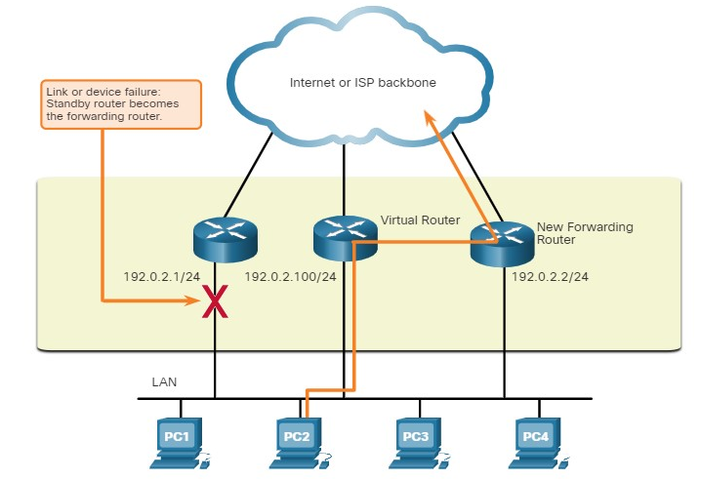

9.1.4

## FHRP Options

The FHRP used in a production environment largely depends on the equipment and needs of the network. The table lists all the options available for FHRPs.

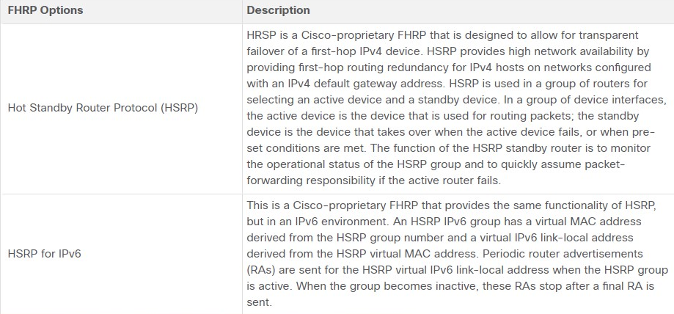

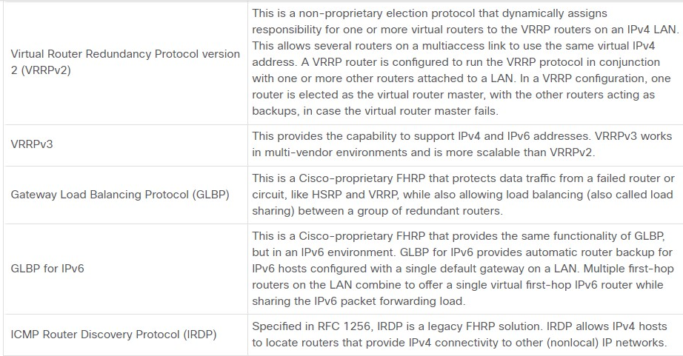

9.3.2

1. What type of device routes traffic destined to network segments beyond the source network segment for which the sending node may not have explicit routing information?



virtual router



standby router



default gateway



Layer 3 switch

**ANS: A device that serves as the default gateway is responsible for routing traffic destined for network segments that are beyond the source network segment**.

1. What device presents the illusion of a single router to hosts on a LAN segment but actually represents a set of routers working together?



virtual router



forwarding router



default gateway



Layer 3 switch

**ANS: A virtual router is actually a set of routers working together to present the illusion of a single router to the hosts on a LAN segment.**

1. What device is part of a virtual router group assigned the role of alternate default gateway?



virtual router



standby router



default gateway



Layer 3 switch

**ANS: A standby router is a device that is part of a virtual router group that is assigned the role of alternate default gateway.**

1. What device that is part of a virtual router group assigned to the role of default gateway?



virtual router



forwarding router



default gateway



Layer 3 switch

**ANS: A forwarding router is a device that is part of a virtual router group that is assigned to the role of default gateway.**

1. Which FHRPs are Cisco-proprietary? (Choose two.)



IRDP



HSRP



HSRP for IPv6



VRRPv2

**ANS: HSRP and HSRP for IPv6 are both Cisco-proprietary. VRRPv2 and IRDP are both non-proprietary protocols.**

**HSRP (HOT STANDBY ROUTING PROTOCOL)**

## HSRP Overview

Cisco provides HSRP and HSRP for IPv6 as a way to avoid losing outside network access if your default router fails.

HSRP is a Cisco-proprietary FHRP that is designed to allow for transparent failover of a first-hop IP device.

HSRP ensures high network availability by providing first-hop routing redundancy for IP hosts on networks configured with an IP default gateway address.

HSRP is used in a group of routers for selecting an active device and a standby device. In a group of device interfaces, the active device is the device that is used for routing packets; the standby device is the device that takes over when the active device fails, or when pre-set conditions are met. The function of the HSRP standby router is to monitor the operational status of the HSRP group and to quickly assume packet-forwarding responsibility if the active router fails.

9.2.2

HSRP Priority and Preemption

The role of the active and standby routers is determined during the HSRP election process. By default, the router with the numerically highest IPv4 address is elected as the active router. However, it is always better to control how your network will operate under normal conditions rather than leaving it to chance.

**HSRP Priority**

HSRP priority can be used to determine the active router. The router with the highest HSRP priority will become the active router. By default, the HSRP priority is 100. If the priorities are equal, the router with the numerically ***highest IPv4 address*** is elected as the active router.

To configure a router to be the active router, use the **standby priority** interface command. The range of the HSRP priority is 0 to 255.

**HSRP Preemption**

By default, after a router becomes the active router, it will remain the active router even if another router comes online with a higher HSRP priority.

To force a new HSRP election process to take place when a higher priority router comes online, preemption must be enabled using the **standby preempt** interface command.

Preemption is the ability of an HSRP router to trigger the re-election process. With preemption enabled, a router that comes online with a higher HSRP priority will assume the role of the active router.

Preemption only allows a router to become the active router if it has a higher priority. A router enabled for preemption, with equal priority but a higher IPv4 address will not preempt an active router. Refer to the topology in the figure.

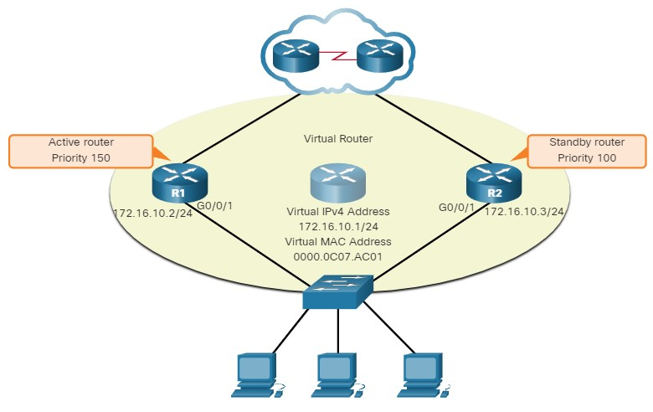

R1 has been configured with the HSRP priority of 150 while R2 has the default HSRP priority of 100.

Preemption has been enabled on R1. With a higher priority, R1 is the active router and R2 is the standby router.

Due to a power failure affecting only R1, the active router is no longer available and the standby router, R2, assumes the role of the active router. After power is restored, R1 comes back online. Because R1 has a higher priority and preemption is enabled, it will force a new election process. R1 will re-assume the role of the active router and R2 will fall back to the role of the standby router.

**Note**: With preemption disabled, the router that boots up first will become the active router if there are no other routers online during the election process.

9.2.3

HSRP States and Timers

A router can either be the active HSRP router responsible for forwarding traffic for the segment, or it can be a passive HSRP router on standby, ready to assume the active role if the active router fails. When an interface is configured with HSRP or is first activated with an existing HSRP configuration, the router sends and receives HSRP hello packets to begin the process of determining which state it will assume in the HSRP group.

The table summarizes the HSRP states.

| **HSRP State** | **Description** |
| --- | --- |
| Initial | This state is entered through a configuration change or when an interface first becomes available. |
| Learn | The router has not determined the virtual IP address and has not yet seen a hello message from the active router. In this state, the router waits to hear from the active router. |
| Listen | The router knows the virtual IP address, but the router is neither the active router nor the standby router. It listens for hello messages from those routers. |
| Speak | The router sends periodic hello messages and actively participates in the election of the active and/or standby router. |
| Standby | The router is a candidate to become the next active router and sends periodic hello messages. |
| Active | The router won the election. |

The active and standby HSRP routers send hello packets to the HSRP group multicast address every 3 seconds by default.

The standby router will become active if it does not receive a hello message from the active router after 10 seconds.

You can lower these timer settings to speed up the failover or preemption. However, to avoid increased CPU usage and unnecessary standby state changes, do not set the hello timer below 1 second or the hold timer below 4 seconds.

You

1. What is the default HSRP priority?



50



100



150



255

**ANS: The default HSRP priority is 100. The priority range is 0-255. The router with the highest priority will become the active router.**

1. True or False? If a router with a higher HSRP priority joins the network, it will take over the active router roll from an existing active router which has a lower priority.



True



False

**ANS; The correct answer is False. HSRP active routers remain the active router even if another router with a higher priority joins the network.**

1. During which HSRP state does an interface begin sending periodic hello messages?



initial



listen



speak



Active

**ANS: In the HSRP speak state the router begins to send periodic hello messages.**

1. Which is a characteristic of the HSRP learn state?



the router has not determined the virtual IP address



the router knows the virtual IP address



the router sends periodic hello messages



the router actively participates in the active/standby election process

**ANS:** **In the HSRP learn state the router has not yet determined the virtual IP address**.

9.3.1

## What did I learn in this module?

**First Hop Redundancy Protocols**

If a router or router interface that serves as a default gateway fails, the hosts configured with that default gateway are isolated from outside networks.

FHRP provides alternate default gateways in switched networks where two or more routers are connected to the same VLANs.

One way to prevent a single point of failure at the default gateway, is to implement a virtual router. With a virtual router, multiple routers are configured to work together to present the illusion of a single router to the hosts on the LAN. When the active router fails, the redundancy protocol transitions the standby router to the new active router role. These are the steps that take place when the active router fails:

1. The standby router stops seeing Hello messages from the forwarding router.
2. The standby router assumes the role of the forwarding router.
3. Because the new forwarding router assumes both the IPv4 and MAC addresses of the virtual router, the host devices see no disruption in service.

The FHRP used in a production environment largely depends on the equipment and needs of the network. These are the options available for FHRPs:

* HSRP and HSRP for IPv6
* VRRPv2 and VRRPv3
* GLBP and GLBP for IPv6
* IRDP

**HSRP**

HSRP is a Cisco-proprietary FHRP designed to allow for transparent failover of a first-hop IP device. HSRP is used in a group of routers for selecting an active device and a standby device.

In a group of device interfaces, the active device is the device that is used for routing packets; the standby device is the device that takes over when the active device fails, or when pre-set conditions are met. The function of the HSRP standby router is to monitor the operational status of the HSRP group and to quickly assume packet-forwarding responsibility if the active router fails.

The router with the highest HSRP priority will become the active router. Preemption is the ability of an HSRP router to trigger the re-election process. With preemption enabled, a router that comes online with a higher HSRP priority will assume the role of the active router. HSRP states include initial, learn, listen, speak, and standby.

## Module Quiz - FHRP Concepts

Top of Form

1. What is the purpose of HSRP?

Topic 9.2.0 - HSRP is a first hop redundancy protocol and allows hosts to use multiple gateways through the use of a single virtual router.



It enables an access port to immediately transition to the forwarding state.



It prevents malicious hosts from connecting to trunk ports.



It prevents a rogue switch from becoming the STP root.



It provides a continuous network connection when a router fails.

1. Which nonproprietary protocol provides router redundancy for a group of routers which support IPv4 LANs?

Topic 9.1.0 - The only nonproprietary FHRP used for router redundancy listed in the options is VRRPv2. HSRP and GLBP are both Cisco proprietary FHRPs. IOS SLB is a Cisco-based solution used to load balance traffic across multiple servers.



GLBP



HSRP



SLB



VRRPv2

1. A network administrator is analyzing first-hop router redundancy protocols. What is a characteristic of VRRPv3?

Topic 9.1.0 - VRRPv3 is a non-proprietary, first-hop router redundancy protocol. It provides features for both IPv4 and IPv6 addressing. HSRP and GLBP are both Cisco-proprietary protocols. GLBP provides load balancing between a group of redundant routers.



VRRPv3 is Cisco proprietary.



It supports IPv6 and IPv4 addressing.



It allows load balancing between routers.



It works together with HSRP.

1. What is a potential disadvantage when implementing HSRP as compared to GLBP?

Topic 9.1.0 - HSRP is a first-hop redundancy protocol that can utilize a group of routers, where a single router is acting as the default gateway and all other HSRP routers will maintain a backup status. GLBP supports load balancing, where multiple active routers can share the traffic load at a single time. Both HSRP and GLBP are Cisco proprietary. HSRP provides default gateway failover when pre-set conditions are met or when the active router fails, and HSRP can support IPv6 addressing.



HSRP does not have the capability to support IPv6 addresses.



HSRP does not provide load balancing with multiple active routers.



HSRP does not function in a multivendor environment.



HSRP provides default gateway failover only when the active router fails.

1. A network engineer is configuring a LAN with a redundant first hop to make better use of the available network resources. Which protocol should the engineer implement?

Topic 9.1.0 - Gateway Load Balancing Protocol (GLBP) provides load sharing between a group of redundant routers while also protecting data traffic from a failed router or circuit.



HSRP



FHRP



GLBP



VRRP

1. When first hop redundancy protocols are used, which two items will be shared by a set of routers that are presenting the illusion of being a single router? (Choose two.)

Topic 9.1.0 - In order for a set of routers to present the illusion of being a single router, they must share both an IP address and MAC address. A static route, BID, or hostname does not have to be shared in this context.



MAC address



hostname



BID



static route



IP address

1. In FHRP terminology, what represents a set of routers that present the illusion of a single router to hosts?

Topic 9.1.0 - In FHRP multiple routers are configured to work together to present to hosts a single gateway router. This single gateway router is a virtual router which has a virtual IP address that is used by hosts as a default gateway.



forwarding router



standby router



virtual router



default gateway

1. A user needs to add redundancy to the routers in a company. What are the three options the user can use? (Choose three.)

Topic 9.1.0 - Three protocols that provide default gateway redundancy include VRRP, GLBP, and HSRP.



STP



HSRP



GLBP



IPFIX



RAID



VRRP

1. Which two protocols provide gateway redundancy at Layer 3? (Choose two.)

Topic 9.1.0 - HSRP (Hot Standby Routing Protocol) and VRRP (Virtual Router Redundancy Protocol) are both Layer 3 redundancy protocols. Both protocols allow multiple physical routers to act as a single virtual gateway router for hosts.



RSTP



HSRP



PVST



STP



VRRP

1. A network administrator is overseeing the implementation of first hop redundancy protocols. Which two protocols are Cisco proprietary? (Choose two.)

Topic 9.1.0 - The first hop redundancy protocols HSRP and GLBP are Cisco proprietary and will not function in a multivendor environment.



IRDP



GLBP



HSRP



VRRP



VRRPv2

1. Which statement describes a characteristic of GLBP?

Topic 9.1.0 - GLBP provides support for IPv6. It provides one virtual IP address and multiple virtual MAC addresses, and there is no such limit of four gateways to provide load balancing.



It provides load balancing for a maximum of four gateways.



It provides multiple virtual IP addresses and multiple virtual MAC addresses.



It provides automatic rerouting if any router in the group fails.



It does not provide support for IPv6.​

1. A network administrator is analyzing the features that are supported by different first-hop router redundancy protocols. Which statement is a feature that is associated with GLBP?

Topic 9.1.0 - The GLBP first-hop router redundancy protocol is Ciscoproprietary and supports load balancing between a group of redundant routers. VRRPv2 and VRRPv3 are nonproprietary protocols and use a virtual router master.



It is nonproprietary.



GLBP allows load balancing between routers.



It uses a virtual router master.



It works together with VRRP.

9.3.3

## Packet Tracer - HSRP Configuration Guide(pending 9.3.3)

**Note**: HSRP configuration is not a required skill for this module, course, or for the CCNA certification. However, we thought you might enjoy implementing HSRP in Packet Tracer. Completing this activity will help you better understand how FHRPs, and specifically HSRP, operates.

In this Packet Tracer activity, you will learn how to configure Hot Standby Router Protocol (HSRP) to provide redundant default gateway devices to hosts on LANs. After configuring HSRP, you will test the configuration to verify that hosts are able to use the redundant default gateway if the current gateway device becomes unavailable.

* Configure an HSRP active router.
* Configure an HSRP standby router.
* Verify HSRP operation.

9.3.4

### **Packet Tracer - Data Center Exploration (PENDING 9.3.4)**

Data Centers are often referred to as the brain of an organization storing and analyzing data, providing communication both internally and to clients, and providing the tools necessary for research and development activities. The data center must be constructed in such a manner that it can securely and efficiently provide its full potential regardless of what catastrophe occurs. There are many different systems that go into the construction of a data center but for this activity we shall concern ourselves only with the networking components.

Data centers can range in size from only a few servers to housing hundreds or even thousands of servers. Whatever the size, the data center must be constructed in an extremely organized manner to simplify management and troubleshooting of a complex environment. Another design characteristic is to make the data center more robust by using redundancy to eliminate any single point of failure. This could involve adding extra devices to provide physical redundancy and/or using technologies such as First Hop Redundancy Protocols (FHRPs) and link aggregation to provide logical redundancy.

In this Packet Tracer Physical Mode (PTPM) activity, most of the devices in the Toronto and Seattle data centers are already deployed and configured. You have just been hired to review the current deployment and to expand the capacity of the Data Center 1 in Toronto.

**Note**: Please be patient. It may take several minutes for this PTPM activity to load.